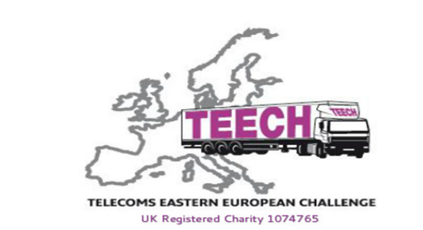

**Aid Donations for Ukrainian Refugees in Moldova**

Moldova (the second poorest country in Europe) is currently welcoming many refugees from its neighbour Ukraine.

TEECH is a charity which has been offering support to the poorest Easter European countries, including Moldova, for many years.

TEECH is run by volunteers and on March 21st 2022 Rab Marshall (of Robertson Marshall Haulage, Edinburgh) is driving a 22-tonne lorry with TEECH to Moldova to offer support for Ukrainian refugees.

Can you please help to fill the lorry with:

*Non-Perishable food*

*Toiletries*

*Sanitary products*

*Washing powder*

*Nappies*

*Sleeping Bags*

*Blankets*

These items can be dropped off at

*Location: Times: Dates: .*

By Sun 20th March when all collections will be gathered and loaded.

For further information contact Annette Marshall (robertsonmhaulage@outlook.com)